2021 Event/Festival Grants
Dickinson County, once again, has authorized funding for grants to be made available within Dickinson County for tourism generating events or festivals. Grant funds are for the marketing and advertising of the 2021 event. Recipients who carried over grant funds from previous years are ineligible.
A written report must be submitted after the event or festival, detailing the following:
- How was the money used?
- What was the estimated turnout/attendance for the event?
- When and where was the event held?
- What was the total expense of the event?
- How was the difference between the grant funds received and the total event expense paid? Would you please detail other funding sources and amounts?
- How did you communicate the receipt of grant funds to the public (IE flyers with sponsorship list, etc.) Please include copies of any advertisements with grants/sponsorships/partnerships listed.
- Please include photos of the event and attendees.
The deadline for submitting a grant request form is August 15, 2021.
* If requests total more than the available amount, your event may not receive the full amount requested. Submission of an application does not imply or guarantee that funding will be available for 2021.

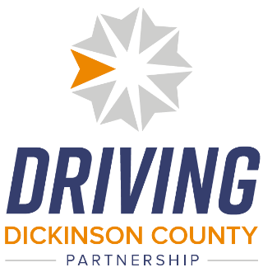
Mail completed request forms to:
Dickinson County Economic Development Corporation
203 NW 15th
Abilene, KS 67410

See next page

2021 Dickinson County Festival/Event Grant Request
- Who is requesting grant funding?
- Event funding is requested for?
- Date of the event/festival?
- How much funding is requested?
- Contact Information:
  - Name:
  - Organization:
  - Address:
  - City:
  - Email:
  - Phone:
- Please use the back of this form or another page to describe the event and provide historical data (Such as attendance in previous years):

* Other documentation may be requested by DKEDC or the County Commissioners of Dickinson County, KS.

Mail completed request forms to:
Dickinson County Economic Development Corporation
203 NW 15th
Abilene, KS 67410

